Biology 346: Wildlife Physiological Ecology
In class Worksheet
Relevant Information:

Lake Naivasha, feeding capacity: 267.2 kJ/day/adult, average clutch size¹ = 4.8
Lake Victoria, feeding capacity: 101.9 kJ/day/adult, average clutch size = 4.6
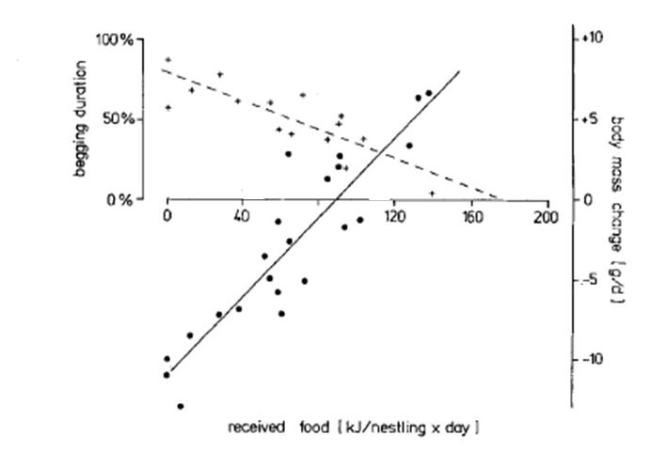
105 kJ/day

Assuming :
-nestlings need to grow 2g/day to be healthy
-only 2 adult birds per nest (no helpers)
-adult birds (parents) do not lose body mass
-adults consistently deliver food according to the above feeding capacity

Answer A as an individual

- How many successful nestlings will birds at Lake Naivasha be able to raise if energy is the only factor constraining clutch size²? Is this number larger or smaller than the average?
How much energy can 2 Naivasha parents bring? 267.2kJ * 2 adults = 534.4 kJ
How much energy does one nestling need to grow 2 grams per day? (get from graph): 105kJ/day
Adults can supply 534.4 kJ, each nestling needs 105 kJ, 534.4/105 = 5.08 nestlings
You can’t grow 0.08 of a nestling, so I’d say they could raise 5 nestlings
Answer B and C as a Group

- How many successful nestlings will birds at Lake Victoria be able to raise (remember, no helpers)? Is this number larger or smaller than the average?
How much energy can 2 Victoria parents bring? 101.9kJ * 2 adults = 203.8 kJ
How much energy does one nestling need to grow 2 grams per day? (get from graph): 105kJ/day
Adults can supply 203.8 kJ, each nestling needs 105 kJ, 203.8/105 = 1.94 nestlings
You can’t grow 0.94 of a nestling, so I would say they can raise 1 nestling
Note: I know the answer you give will depend on the number you estimate from the graph. That’s fine.

\

- Assuming Lake Victoria starts accepting helpers, how many helpers do parents at a nest need to accept at Lake Victoria in order to raise an equal number of nestlings (that you calculated in A) as Lake Naivasha?
I calculated that a Naivasha pair could raise 5 nestlings. For a Lake Victoria pair to raise 5 nestlings, they would need to bring in 105 kJ * 5 nestlings = 525 kJ of energy.
If each Victoria adult can bring 101.9 kJ, there would need to be 6 adults total (101.9*5 = 509.5 which is not enough to raise 5 nestlings (525 kJ). So there would need to be 6 adults. 2 of those are the breeding pair, so they would need to accept 4 helpers.
Note: again, if you estimated less than 105 kJ needed per nestling then your answer may have been 3 helpers, not 4. That’s fine.

- Average clutch size means average number of eggs laid in a nest. (I.e. if the average clutch size is 5, then 5 eggs are laid in the nest).
- For this particular question, ignore the average clutch sizes given above. Assume parents will have as many offspring as they possibly can.

